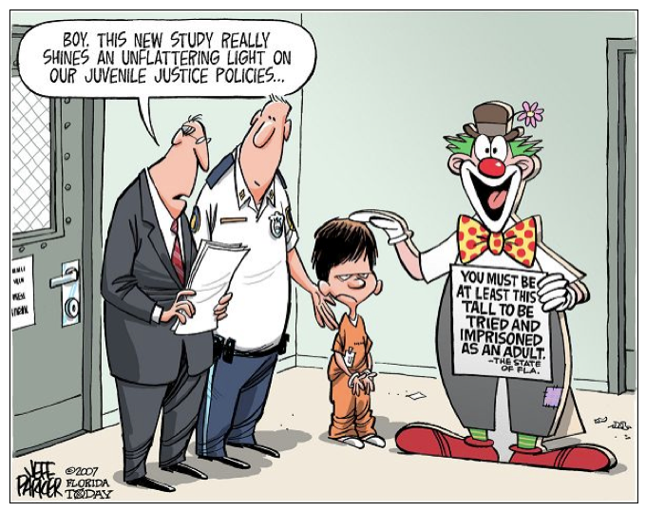

Mr. Pearce

"Frontline: Juvenile Justice." *PBS*. Web. <http://www.pbs.org/wgbh/pages/frontline/shows/juvenile/>.

Source

Facts About the

Juvenile Justice System

## Juvenile Offenses

**What the studies show…**

**Adult sentencing is assumed to:**

* Provide harsher and more proportional punishments to the crimes
* Lower juvenile crime rates due to the threat of harsher punishment

To date, there have been no major studies done to test the assumptions. The research that has been done , however, shows no sign that adult sentencing has any effect on juvenile crime rates.

**Juvenile crime accounts for a yearly average of:**

* 16% of all violent crime arrests
* 32% of all property crime arrests
* 54% of all arson arrests
* 42% of all vandalism arrests
* 31% of larceny-theft arrests
* 33% of burglary arrests

# Controversy in the Courtroom

There is much controversy in the trial of juvenile offenders. In many cases, the term “age of majority” comes into the picture. Defined as the age at which the rights and privileges of an adult are legally granted, “age of majority” is a legally fixed age (set by jurisdiction) that may not necessarily correspond to the actual physical or mental maturity of an individual. **However**, by judicial waiver, courts can transfer juvenile cases to the adult system. There are laws that establish a minimum age that offenders must fall under to be tried as an adult.

**Pennsylvania’s minimum waiver transfer age is currently 10.**

* Of all juvenile court cases, just over 1% are dealt with in the adult court system.
* Fewer than half of serious violent crimes by juveniles are reported to law enforcement.
* An estimated 2.5 million juveniles are arrested each year, most commonly for nonviolent crimes like theft.