Project Proposal
Incorporating Technology for Efficient Instruction Within the Music Classroom
Instructional Design Documentation

Nathan Pearce
ED 540
Spring 2011

1.0 Purpose and Overview
Our purpose is to enhance the efficiency of instruction through the implementation of technology in Mr. Steffanina’s classroom. Mr. Steffanina will be trained on how to use and deliver instruction through various forms of technology. By using these tools, Mr. Steffanina can reduce the amount of class time needed to cover specific content.

2.0 Personnel
2.1 Identification:
The primary client and subject-matter expert is Mario Steffanina, music educator and band director at the Titusville School District. Nathan Pearce will serve as the project manager and lead instructional design specialist.

2.2 Expectations:
The client/subject-matter expert is responsible for providing all the necessary resources needed to effectively develop and design the desired instruction. The project manager/lead instructional design specialist has responsibility over the completion of the project following the agreed upon timeframe.

3.0 Project Communications
The project manager/lead instructional design specialist will communicate weekly, either through email, text messages, by phone, or in person with the client/subject-matter expert. Communications will cover accomplishments, ideas, changes, and modifications dealing with the project. Various one-on-one meeting times will be scheduled throughout the project in order to share insight, provide feedback, and to share problems and concerns dealing with the project in its entirety.

4.0 Project Goals
- Train Mr. Steffanina in the use and design of the decided upon applied technology for future adaptations.
- Reduce the total class time by which Mr. Steffanina uses to find, select, and play clips of audio as examples to his class.
- Assess Mr. Steffanina’s mastery of new technological sckills.
5.0 Tentative Project Schedule
January 22 | Kick off communication (casual brainstorming between both parties).
February 5 | Determine problem and assess appropriate solutions.
February 18 | Determine instructional content.
March 11 | Evaluate student abilities and prior knowledge.
March 18 | Identify appropriate technology medium to be used for instruction.
March 26 | Create measurable goals and objectives for learners.
April 9 | Begin development of instructional materials.
April 15 | Instructional materials completed for implementation.
April 22 | Create student evaluation (survey) of new instructional method.

6.0 Resources
The client will act as the subject-matter expert and provide all the necessary materials and resources needed to execute the project. This includes any books, notes, and information gathered from various sources pertaining to the content integrated into the project. Also, the client will be responsible for providing the appropriate technology to effectively administer the designed instruction.

7.0 Deliverables
A number of products will be delivered:
(1) Technological instruction, training, and assessment
(2) Instructional materials
(3) Student feedback survey/evaluation (formative assessment)

8.0 Evaluation
All materials and plans will be reviewed throughout the project. Ongoing revision will occur throughout the design and development process. Following scheduled delivery, students will provide evaluation of the implemented technology in the form of a survey.

9.0 Renegotiation
All parts of this proposal may be revised and rewritten at any time by either the client/subject-matter expert or the project manager/lead instructional design specialist. Both parties share this responsibility in the event that the need for renegotiation becomes an issue.

Problem Identification
Executive Summary
Lessons in music education can be taught in many different ways. Theory and history can be read about in wordy texts, styles and composition can be discussed in groups, and mechanics can be lectured about. In a general music class, however, the best way to reach students with new material is to connect that material with music. This can be delivered in the form of recordings or live instrumentals within the classroom. However, the downside to instruction with musical examples is the amount of time listening to audio takes away from instruction. In Mr. Steffanina’s class, a lot of time is taken away from actual instruction by changing discs in a CD player, selecting tracks, and skipping to the appropriate portions within each composition. A more efficient way of instruction that still includes the valuable audio examples is proposed for development

Needs Assessment
For an average lesson, Mr. Steffanina will play 3-5 audio clips that pertain to instruction. Whether the clips are related to a composer, a style of music that the class is covering, or a particular method within music theory, time has to be spent away from instruction to facilitate the playback of the audio. On average, 5-10 minutes of class time can be spent setting up, selecting, and playing the appropriate audio clips for the class. In a ~45 minute class period, over 20% of the class time can be spent facilitating this audio to the class. Mr. Steffanina needs a more efficient way to deliver these resources to the class.

Goal Analysis
Set Goals
- Reduce “wasted” instructional time
- Select audio to be used in the course
- Edit audio clips to ~30-60 second examples
- Archive all audio digitally for efficient use
- Label and catalogue audio for efficient locating
Refine Goals
- Select and crop audio clips for instruction
- Label, catalogue, and store audio clips digitally

Rank Goals
- Determine what audio tracks fit appropriately into instruction
- Select a segment of each track for playback in class
- Rip each audio track into a digital format on a computer
- Trim the digital tracks down to desired segments
- Label and catalogue each segment
Second Refinement
- Convert audio to digital format
- Trim into segments
- Label segments
Final Ranking
- Select audio tracks to be played in class and convert them to a digital format
- Trim digital audio tracks into appropriately labeled segmented clips
Recommendation
To make Mr. Steffanina’s music class more efficient in the use of instructional time, it is my recommendation that the following measures be taken. Mr. Steffanina will be trained to convert audio that is used during instruction into succinct, digital segments that can be easily located and presented during instruction, limiting the amount of time spent in preparation and selection of pieces of musical examples.

Learner Analysis
General Learner Characteristics
The learners in Mr. Steffanina’s music classes are both male and female students in grades 9 through 12. Each class period is composed of a mixture of these students from the four grades. The school district is located in a rural area of western Pennsylvania, and student family income ranges from low to middle class. In general, most students perform at or above their grade’s reading level, however there are some exceptions; many of Mr. Steffanina’s students have IEPs that must be followed. Most of the IEPs include simple reading strategies that should be incorporated within lessons involving text, and generally, the IEP students do not affect Mr. Steffanina’s instructional plans in a major way.
Specific Entry Competencies
Prerequisite Skills
Mr. Steffanina’s music class does not have a set of prerequisites for enrollment. Any student prior knowledge comes from previous music courses throughout their personal academic careers and is not necessary for the completion of this particular class. This course acts as a stand-alone, general study of music, and all necessary concepts are directly taught within. However, it is necessary for students to have adequate reading skill to be able to participate in this class.
Attitudes and Aptitudes
To be successful in Mr. Steffanina’s class, learners must be willing actively participate in classroom activities and projects throughout the school year. Seeing as how the class is a free elective course that the students actively choose to take, this should not be much of a problem. For the most part, the students are active in class and participate in all of the activities willingly. However, motivational strategies need to be integrated into this class just like any other high school class.
Learner Styles
Perceptual Preferences and Strengths
Within the music classroom, students have to be comfortable with all four types of perceptual learning. Auditory learning becomes relevant whenever audio clips are played for students to hear. Visual learning is needed in order to recognize and read music notes on a staff. Both tactile and kinesthetic learning is factored in when students play musical instruments directly in hands-on lessons. Having strengths/preferences in any of these perceptual fields is fine, but weaknesses will slow down the learning process, therefore, it is recommended that well-balanced learners enroll in the course. Mr. Steffanina’s students tend to have strengths in auditory learning making the presentation of musical examples a great tool in the classroom. His students also do well when learning hands-on with instruments.
Information Processing Habits
Students who do well in a scaffolding based classroom will be likely to succeed in Mr. Steffanina’s music class. The course is designed to build upon its own concepts and theories in a way that allows learners to make connections and see similarities within the material. Generally, most high school aged students will find this presentation of information to be easily processed.
Motivational Factors
Students within the music classroom are generally intrinsically motivated to do well within the course. Because they actively select the course when scheduling as one of their elective, they generally show an interest in the content. Mr. Steffanina also uses a lot of motivational strategies within his classroom that aid in the overall achievement of students.
Physiological Factors
Physiological differences do not really have much of a bearing on Mr. Steffanina’s class. Both males and females achieve on the same academic level. None of his students possess any hearing impairments. Visual impairments do exist, but those students with visual problems wear corrective lenses and have the option of sitting in the front of the class.

Contextual Analysis
Orienting Context
Learners enrolled in this course mostly expect a general exploration of music as a whole, seeing as how the course acts as a free elective. Areas that are explored through instruction include theory, practice, and performance along with many other disciplines. However, one thing that needs to be greatly stressed by the instructor is the importance of student participation and willingness to be responsible for their grades within the class. Because the class is an elective, students tend to scale down the importance of their achievement within the course.
Instructional Context
The course is designed in a way that fits the boundaries of Mr. Steffanina’s music room well. Constant access to a video projector and audio equipment is something that is always available. Coursework designed to be done with the use of the computers, however, is not as easily completed by the students. Mr. Steffanina’s music room has it’s own small computer lab with only enough computers to accommodate half of his students at any given time. Instruction using the computers has to either be designed to be worked on in pairs or independently by half of the group while the other half receives direct instruction.
Transfer Context
Coursework is designed to complement and build off of itself. Concepts learned early on in the course become important factors in more complex concepts as instruction progresses. Confirmative assessment strategies work well within the course due to their functionality of providing ongoing assessment of basic concepts. Testing understanding of all concepts throughout the course will ensure that the appropriate connections are made between topics and lessons.

Task Analysis
Narrative:
Based on the previously conducted needs assessment, it is clear that the way in which tasks involving listening to musical examples in class are being conducted in very inefficient ways. Close to 20% of a ~45 minute class period can be wasted selecting and playing portions of audio examples. This does not have to be the case if certain actions can be taken in order to streamline the process of providing these audio examples for the students. These actions would include trimming, archiving, and saving audio files in ~30 second clips that are stored for quick and easy access, both in the classroom and online for student reference on their own time.
Method:
In this instance, a topic analysis of the cognitive task would work best. Identifying the steps needed to complete the specified task (streamlining instruction involving audio examples) is critical to the outcome of the instructional design.
Analysis:
- Select the musical concepts and theories that will be covered throughout the course.
  - Concepts should be derived from and based off of academic standards.
- Find pieces of music that highlight the selected concepts and theories directly in through their composition.
  - Textbooks, internet sources, and supplemental materials can be used to find examples.
  - Teacher audio CDs included with textbook will provide some usable audio.
- Rip music into a digital format on the computer.
  - iTunes can be used as it is a free, widely used software that is supported on multiple platforms.
- Listen for the selected concepts and theories within the musical pieces.
- Select a 30-45 second clip from each piece of music that best illustrates a desired concept or theory.
- Trim, save, and label each clip according to the name of the musical piece and the concept/theory it represents.
  - Select an appropriate labeling format (i.e. Concept-Artist-SongTitle) to be used throughout
  - Consistency within labeling will allow for more efficient access of audio files.

Objectives and Presentation Strategies
Objective 1
After a music example is selected, Mr. Steffanaina will be able to rip a digital audio file from a physical copy in less than two minutes.
(Procedure – Application)
Initial Presentation
A video made using screen-capture tools will be shown to Mr. Steffanina, detailing the step-by-step process that can be used to take audio from a CD and turn it into a digital file on the computer.
Generative Strategy
Mr. Steffanina will orally list the steps necessary to convert audio from a CD into a digital audio file using a computer.
Test Items
Timed procedural assessment – demonstrates entire process from CD to short digital clip.

Objective 2
Mr. Steffanina will be able to trim full-length digital audio files into 30-45 second clips in less than three minutes.
(Procedure – Application)
Initial Presentation
An instructional video will be shown to Mr. Steffanina that highlights the steps necessary to select, trim, and label audio clips using a computer.
Generative Strategy
Mr. Steffanina will practice creating audio clips in this method using audio examples used in past lessons.
Test Items
Timed procedural assessment – demonstrates entire process from CD to short digital clip.

Objective 3
Mr. Steffanina will be able to locate and play any desired audio clip in less than 30 seconds.
(Procedure – Application)
Initial Presentation
Mr. Steffanina will be shown, in a one-on-one demonstration, how to navigate, select, and play audio clips after they have been converted into digital files and trimmed down into short selections.
Generative Strategy
After being shown a demonstration, Mr. Steffanina will describe the steps taken to locate and play audio clips.
Test Items
Timed procedural assessment – demonstrates entire process from CD to short digital clip.

Learner Assessment Instrument
Following instruction, Mr. Steffanina will be assessed on his ability to complete the process of taking audio from a CD and going through the steps needed to have a final product that is a short digital audio clip that is easily located and played.
The assessment will be given under the following conditions:
- Mr. Steffanina will be given 5 separate audio CDs
- A list of songs (2 from each CD) with a 30 second portion (ex. 1:34 – 2:04) will be presented to Mr. Steffanina
- Mr. Steffanina will be given a total of 60 minutes to create all 10 audio clips
- Following the initial 60 minutes, Mr. Steffanina will be required to locate and play each clip, selected at random by the test administrator, in an allotted amount of time (less than 30 seconds per clip)
The following scoring checklist will be used for assessment:
Skill: | Exceeds | Meets | Does Not Meet
Ability to rip audio from a CD in a timely manner (< 2 min/song)
Ability to trim and label selections of digital audio efficiently (< 3 min/song)
Ability to quickly locate and play audio clips (< 30 sec/song)

If Mr. Steffanina meets or exceeds in all three sections of the test, he has successfully completed the training. If one or more of the skills are not met within the timeframe, further instruction will take place with a repeat assessment to follow.

Unit Plan
Mr. Steffanina’s training will take place in a 3-day block and will cover all of the planned objectives. Each session will be 45 minutes in length. Below is a breakdown of each day:
Day | Objectives Covered | Sequencing Strategy | Instructional Strategy | Pre-instructional Strategy
1 - Introduction | N/A | World-Related | Demonstration, Organization | Advance Organizer
2 - Practice | 1, 2, 3 | World-Related | Model, Elaboration, Practice | Overviews
3 - Assessment | 1, 2, 3 | World-Related | Application | Behavioral Objectives

Day #1 – Introduction
Day one will begin with Mr. Steffanina being introduced to the instructional goals and objectives. After familiarity with these items is achieved, a demonstration of the process by which Mr. Steffanina will use to promote efficiency in his music instruction will be shown. Accompanying the demonstration will be an organizer that details all the steps of the process that are being presented. This organizer will be used to assist Mr. Steffanina in practicing the skills and tasks the following day.
Day #2 – Practice
On day two, the focus will be hands-on practice. Using the organizer provided on the first day, Mr. Steffanina will follow along with a model of the full task from start to finish. After the demonstration, Mr. Steffanina will have a chance to ask any questions or ask for certain steps of the process to be shown again, elaborating on certain aspects. Following the questioning period, Mr. Steffanina will be given the remainder of the session practicing the task while being offered assistance and guidance.
Day #3 – Assessment
The final day will consist of the assessment. However, before beginning, Mr. Steffananina will be allotted a small amount of time to ask questions and practice momentarily. The assessment will then commence, and the instructor will use the assessment instrument to measure Mr. Steffanina’s completion of each objective.
If the performance is below satisfactory, the steps of day three will be repeated on the following day.
Instructional Materials
Handout – Organizer
Instructional Objectives:
- After a music example is selected, Mr. Steffanaina will be able to rip a digital audio file from a physical copy in less than two minutes.
- Mr. Steffanina will be able to trim full-length digital audio files into 30-45 second clips in less than three minutes.
- Mr. Steffanina will be able to locate and play any desired audio clip in less than 30 seconds.

Process:
This chart will walk you through the process of taking a physical copy of a song on a CD, turning it into a digital file, clipping it down to a small segment, and saving it for easy access.
Locate CD containing desired audio and insert it into your computer.
The program iTunes should automatically open. If not, locate the iTunes icon in the dock and click on it to open the software.

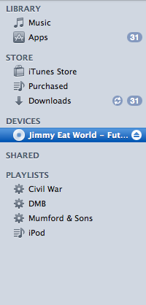
The next step is to locate the audio CD within iTunes. Click on the CD icon on the left side of the screen.

On the right side of the screen, locate the desired song(s) and make sure that the check boxes are selected.

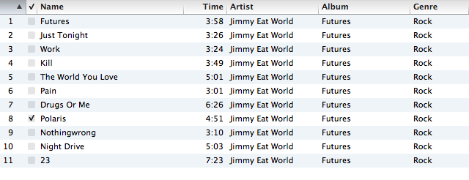

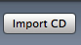
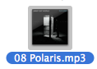
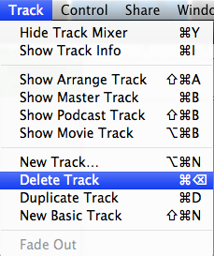
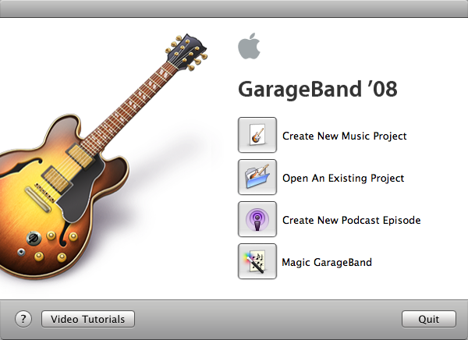
Once the desired tracks are checked, locate and click the Import CD button in the bottom right part of the screen.
Locate the file in the “Finder” and drag it into GarageBand.
Once in the program, delete the “Grand Piano” track by locating “Delete Track” from the above dropdown menu.
Open GarageBand from your dock and click on “Create New Music Project.”
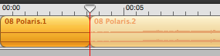
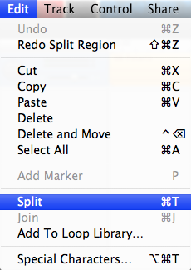
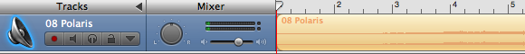
Select the first segment of the clip to be removed and press the “delete” key.
From the “Edit” menu, select “Split.”
Move the playhead to the start of the desired clip.
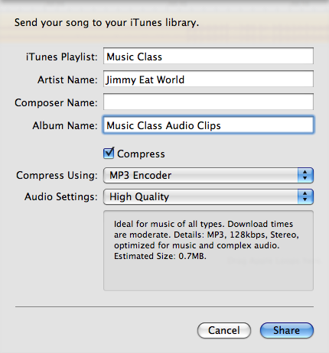
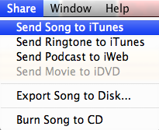
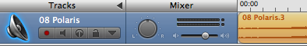
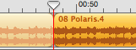
Appropriately label the clip and click “Share.”
From the “Share” menu, select “Send Song to iTunes.”
Drag the trimmed clip to the very beginning of the track position.
Repeat the last three steps to select and delete the audio behind the end of the desired clip.
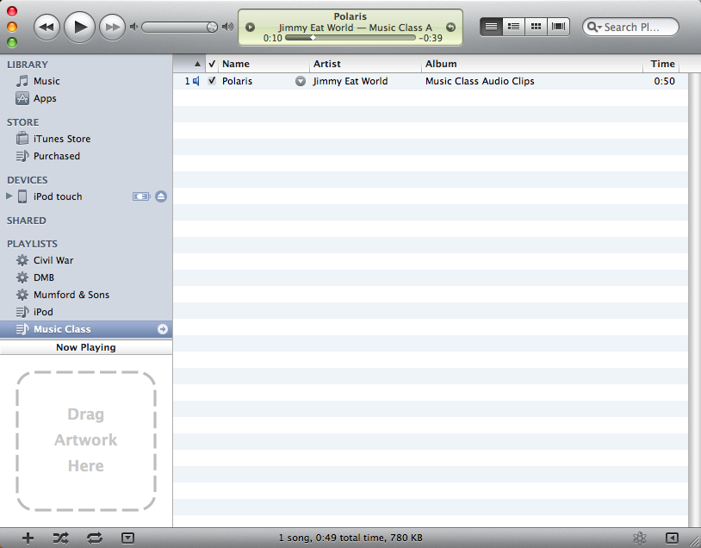
You should now be able to efficiently locate and play each clip through iTunes. Repeat as necessary.
Formative Evaluation
During technological instruction, Mr. Steffanina’s progress will be assessed formatively through observation and questioning. Listed below is a breakdown of formative assessments for each day of instruction.
Day #1 – Introduction
- Questioning (familiarity with goals and objectives, procedures, etc.)
- Notes (taken during demonstration following along with organizer)
Day #2 – Practice
- Questioning (process)
- Observation (procedural capabilities)
Day #3 – Assessment
- Questioning (pre-assessment)
- Observation (during assessment)
Summative Evaluation
The overall success of this design will be assessed at a summative level through a post-integration observation and student survey.
After Mr. Steffanina has learned this method to its full capacity, a formal observation will be conducted to observe and assess the effectiveness of the new instruction. As part of the summative evaluation observation, a student survey will be issued that critiques the newly incorporated instruction process.

Student Survey
1. After being taught using the new method, about how much class time do you feel was saved?

2. Did you find this method of instruction to make the class flow in a more productive way?

3. Were you able to adjust easily to the new instruction?

4. Would you prefer to use this method of instruction from now on?

5. Do you have any suggestions or comments to make about the use of technology?

6. Please list any additional concerns or critiques…

